Name : Luthfi Ali Qodri

Class : X RPL 2

COMPANY PROFILE SMK TARUNA BHAKTI

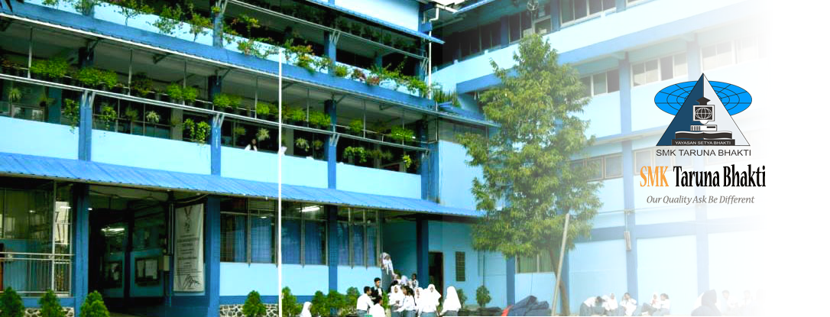

To meet the need for high quality human resources in the mastery of science and technology based on the spirit of faith and taqwa, SMK Taruna Bhakti Depok is designed to equip students to master the science, especially in the field of Information and Communication Technology quality, and have life skills. The learning program of SMK Taruna Bhakti gives special attention to the mastery of ICT especially in Computer and Network Engineering (TKJ), Multimedia (MM) and Software Engineering (RPL) by using National curriculum which is innovatively enriched by SMK Taruna Bhakti based on VISION , MISSION, OBJECTIVES and TARGET SMK Taruna Bhakti.

In addition to in-class (intracurricular) learning and talent / interest development through extracurricular, students expand their insights through a variety of programs that equip students to have life skills such as: Character Building, Science Camp, Bringing Guest Teachers from the relevant Business / Industry etc, as well as giving students widespread opportunities to compete in academic and non-academic fields at National, Regional and International levels.

**The Establishment Of SMK Taruna Bhakti depok**

Starting from junior high school students who live in the District of Cimanggis Depok to continue their education to senior high school / vocational school, and still the lack of SMK facilities in the District Cimanggis.

Setya Bhakti Foundation in this case who has first had SMP Taruna Bhakti Depok which was established from 1987 and has about 1200 students. On that basis yayasa setya Bhakti is a higher education facility that is SMK Taruna Bhakti Depok, with the hope that most of SMP taruna Bhakti can be accommodated in SMK Taruna Bhakti Depok environment.

So with the determination that has been done on June 16, 2004 founded SMK Taruna Bhakti Depok located in Jalan Pekapuran Curug Village Cimanggis Depok District. With Field Study "Information and communication technology" and competence "Computer and network engineering".

When first standing school with the condition of three permanent study rooms but not yet equipped with windows and door of the room. In the first year of standing SMK Taruna Bhakti has 3 study groups with a total of 126 students. With a total of 13 teachers. In the first year of the 2nd semester of SMK Taruna Bhaki only has 1 Room which is functioned as Computer Laboratory.

In the second year of SMK Taruna Bhakti get students with the number 64 students, far from the first cost for the cost of education in the area of ​​SMK Taruna Bhakti Depok.

**Vision of SMK Taruna Bhakti**

Produce graduates who are competent in Science and Technology, and able to compete at national and global level.

**The mission of SMK Taruna Bhakti**

1. Growing spirit of creativity, synergy and competitive to all citizens of the school
2. Implement the curriculum through competency-based learning and assessment, entrepreneurial based, environmentally sound and grounded in honesty.
3. Improving the quality of human resources through certification of National and International Competency
4. Developing potential learners through Interests and Talents activities and discipline building.
5. Implement excellent service in school management through Quality Management System

**The purpose of SMK Taruna Bhakti**

1. Produce competent graduates
2. Improve the quality of learning.
3. Preparing learners to be able to develop a professional attitude, able to adapt and compete
4. Increase public satisfaction to obtain education services
5. Consistency of implementation of activities, quality control and quality assurance of schools.
6. Improve the welfare of the school community.

In all Educational Process activities apply the culture of quality as follows:

1. The change is the future
2. Excellent service
3. Learning without practising is nothing
4. Service is investment
5. Our quality ask be different

**Vocational course in SMK Taruna Bhakti**

In the 2016/2017 Lesson Year SMK Taruna Bhakti has 1600 (40 Rombel) students, consisting of 5 competency skills:

1. Computer and Network Engineering (17 rombels)
2. Multimedia Engineering (9 rombels)
3. Software Engineering (7 rombels)
4. Broadcast (5 rombels)
5. Industrial Elektonika Engineering (2 rombels)